At the heart of the Wisconsin Idea lies the confluence of expertise and democracy, an enduring testament to the philosophy that the boundaries of a university should extend beyond its campus, permeating every facet of societal advancement. This principle, deeply rooted in the Progressive Era's reformative spirit, articulates a vision where the University of Wisconsin harnesses its scholarly resources to illuminate the pathways of public policy and governance. Instead of confining academic excellence to the ivory tower, the Wisconsin Idea encourages the university to use its knowledge to catalyze positive change. As experts in their respective fields, Professors play an integral role in the realization of the principle of expertise and democracy, as they have a responsibility to use their expertise to benefit the public good. This idea is not without opposition, however. Adversarial opinions contest that Professors should remain distinctly separate from governance, and use the growing distrust of expertise to galvanize support for their claims. While the topic may be polarizing, it is abundantly clear that the University of Wisconsin has a storied history of interacting with public policy to better the world surrounding it and continues to contribute to society in immensely important ways.

In keeping with the original message of the Wisconsin Idea, early efforts by University professors were focused on improving quality of life for various stakeholders throughout Wisconsin. Stephen Babcock, the chair of the agricultural chemistry department, was one of these individuals. Babcock focused his research on answering questions that would help Wisconsin farmers. Most famously, he developed the Babcock Test(link), which was an inexpensive procedure by which the butterfat content of milk could be determined. Rather than patenting the test, Babcock opted to allow all farmers in the state to use it as they saw fit. As a direct result of Babcock’s actions, Wisconsin dairy production rapidly expanded, and Wisconsin dairy farmers gained a competitive advantage over dairy farmers in other states. Charles McCarthy was a professor of Political Science at the University of Wisconsin-Madison, and he sought a way to improve the process through which bills were researched and drafted. He created the first of its kind Wisconsin Legislative Reference Bureau(link), which has grown to be responsible for drafting nearly all of the legislation for the state of Wisconsin.

As the university–and our world–become more globalized, the university has the capacity to impact the world on a larger scale. This expands past the boundaries of the state–which was the Wisconsin Idea’s initial concern–and even the nation. While this may seem to contradict the original meaning of the Wisconsin Idea: to serve the state and its constituents, economic and political success are different today than they were sixty years ago. Positive impacts on a larger scale can still be immensely important to the individuals who live in Wisconsin. Five examples of significant developments, headed by university Professors, that have largely benefited the entire country are the creation of weather satellites that descended from designs from UW professor Verner Suomi, the development of Social Security by Edwin Witte, advancements in space-based astronomy led by Professor Arthur Code, key developments in organ transplant medicine by the School of Medicine and Public Health, and scientific breakthroughs in stem cell research by Professor James Thomson. There is no question that all of these developments benefit the individuals living in the state of Wisconsin. While the university’s service to its home state may have been more explicit and direct decades ago, the desire to utilize education to enhance the lives of people outside of the classroom–whether through applied research or influence on public policy–is still a major component of the university’s mission.

For more in depth analysis, check out this link: <https://news.wisc.edu/uws-175th-five-ways-uw-madison-ideas-have-changed-the-world/>

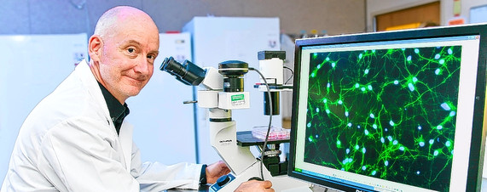

Professor Thomson–Stem cell

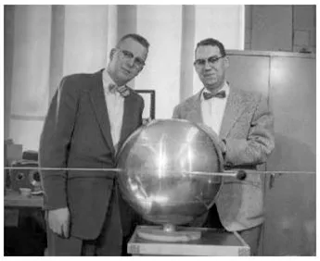

Verner Suomi with an early satellite

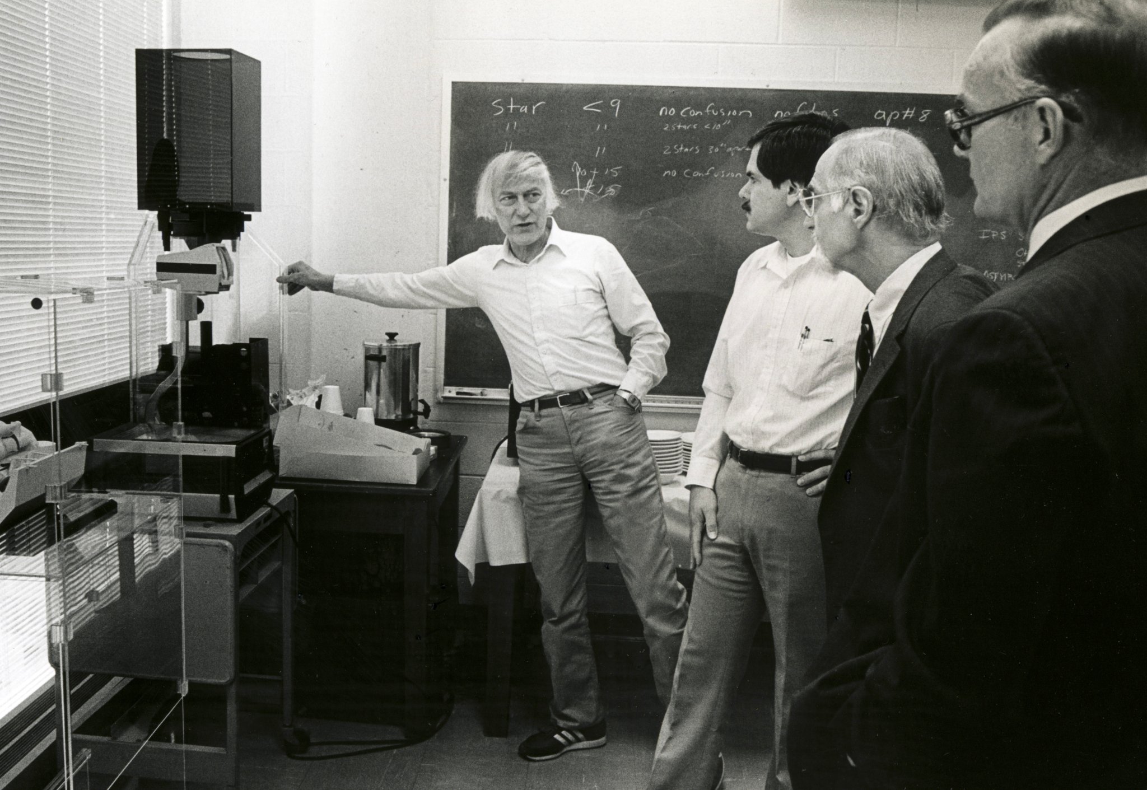

Professor Arthur Code–Developments in Spaced-Based Astronomy